

***Exor Corporation Limited***

**The Global Leader in**

**Infrastructure Asset Management**



**Navigator and Query Builder**

**User Guide v4.3**



This page intentionally blank

#### 

Quality Assurance Statement

|  |  |
| --- | --- |
| Document Details | |
| **File:**  Navigator and Query Builder  User Guide v4.3.pdf | **Prepared by:**  Ian Skinner |
| **Manual Name:**  Navigator and Query Builder  User Guide v4.3.pdf | **Reviewed by:**  T.C.Stewart |
| **Version:**  3.0 | **Approved for issue by:**  T.C. Stewart |
| **Date of Issue:**  November 2010 | **Product Manager:**  T.C. Stewart |
| **File Name:**  Navigator and Query Builder User Guide v4.3.pdf | |

|  |  |  |  |  |
| --- | --- | --- | --- | --- |
| **Document Version Control** | | | | |
| **Revision** | **Date** | **By** | **Page** | **Description** |
| 3.0 | Nov 2010 | IS | All | Released for version 4.3 |

CONTENTS

Quality Assurance Statement 3

Navigator - NAVIGATOR 5

Query Builder – Standard Query Panel 6

Query 7

Query Criteria 9

Query Builder – Advanced Query Panel 11

Attribute Criteria Panel 12

Saving the Query Criteria 14

Loading a Saved Query 15

Deleting a Saved Query 16

Results Grid 17

Hint Text 18

Sorting Results 19

Selecting Data Items from the Grid for Display within a form 20

Selecting a Data Item from the Grid for Display within navigator 20

Navigator Panel 21

Additional Examples – Work order Lines 26

Additional Examples – Enquiries 27

Additional Examples – Multiple Records 28

Navigator - NAVIGATOR

Figure 1

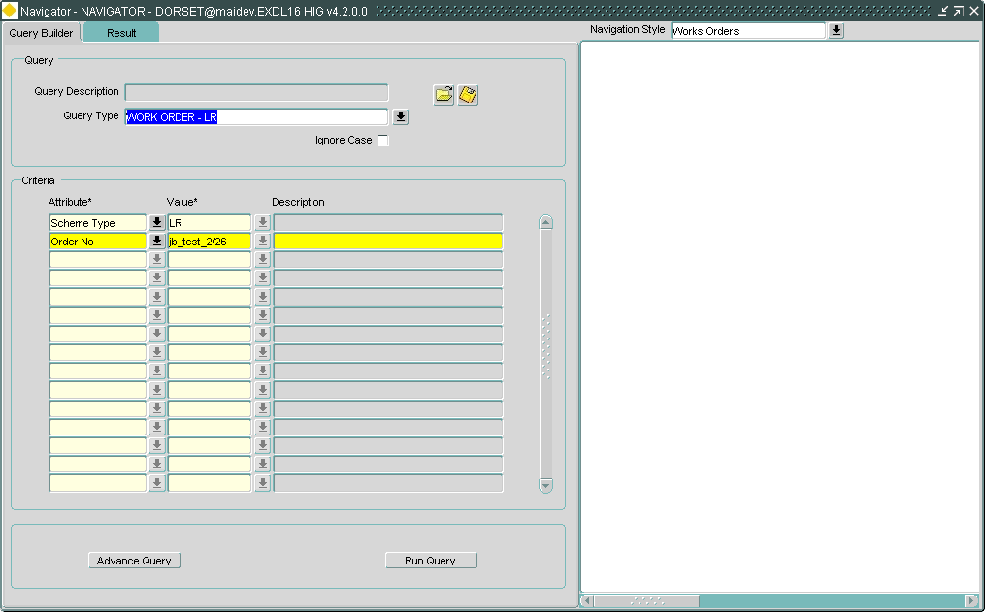

The navigator form can be called from the following:

* Fastpath, using ***NAVIGATOR*** as the module id
* Menu, Asset Manager/Asset Management/EXOR Navigator
* From the following forms
  + Enquiries – DOC0150
  + Work Orders – MAI3800
  + Defects – MAI3806
  + Work Order Authorisation Worktray

The navigator form has two main areas

* Query Builder and Results tabs
* Navigator panel

Query Builder – Standard Query Panel

The Query panel within ***Query Builder*** is used to enter the data type and attribute values for which to query.

Once defined, the Query criteria may be saved for future use using the save icon  adjacent to the ‘Query Description’ field (Figure 8).

Query Builder allows the user to build and save queries that apply to any asset that has been defined within the ***Asset Metamodel – NM0410*** including:

* General Inventory Items
* Road Condition Data
* Road Construction Data
* External Assets (defined by the system administrator)
* Derived (composite) Assets
* Alert and Audit Metamodels
  + Work Orders, including flexible attributes
  + Work Order Lines
  + Enquiries
  + Defects
  + BOQ Items
  + Process Alerts (alerts generated as a result of the process automation facility)

These queries are generated irrespective of network restrictions that affect the data.

The Attributes available as search criteria are restricted to Attributes of the selected Object Type that have been flagged as ‘Queryable’ in the ***Asset Metamodel – NM0410*** module. Figure 2 shows an example of the Queryable flag being set..

Figure 2

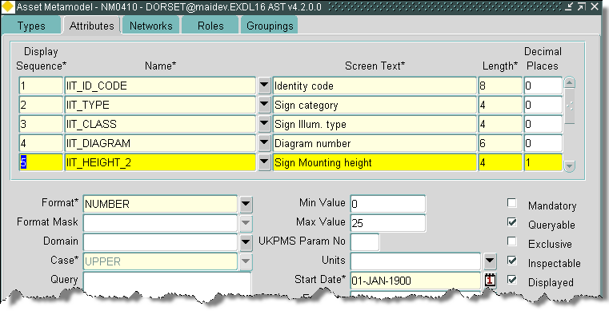

Queryable Attributes will be ordered as per the ‘Display Sequence’ number defined for the Attribute.

To remove attribute columns from the results grid uncheck the ‘Displayed’ checkbox.

Figure 3

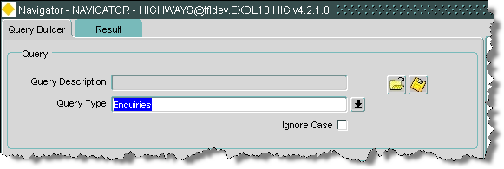

Query

The ‘Query’ panel of the ***Navigator*** module is used to define the object type, e.g. Gully, Work Order etc., and attribute values for which to search. Once the search criteria have been entered they can be saved for future use using the **[Save]** icon adjacent to the ‘Query Description’ field.

Query Description (Display Only)

The description of a saved query that has been selected for re-use will be displayed. .

To load a saved query select the folder icon . Full details on loading a saved query are shown in Figure 9.

To save a query select the save icon . Full details on saving a query for re-use is shown in Figure 8.

Query Type (Required) (List)

Enter the required Object Type or select from the allowable list of values. ***Query Builder*** uses the Object Type description, e.g. ‘*Enquiries’* and not the Object Type code, e.g. ‘*ENQ$’* when displaying and validating the Object Type for which to search.

If the user wanted to search for ‘ENQ$’ they would select the picklist and search to the right of the % in the find field, for example ‘%EN’ would search for everything with ‘EN’ in the description or the type fields.

***Query Builder*** uses ‘Auto Complete’ when the entering the ‘Query Type‘. For example, if ‘*E*’ was entered, upon exiting the field the system will atomically populate the field with the appropriate Object Type that begins with ‘*E*’. If more than a single Object Type matches the text string entered, a list of potential values is displayed allowing the User to select the required Type. The list of values displays the Object Type description and is sorted in alphabetic order as shown in the example in Figure 4

.

Figure 4

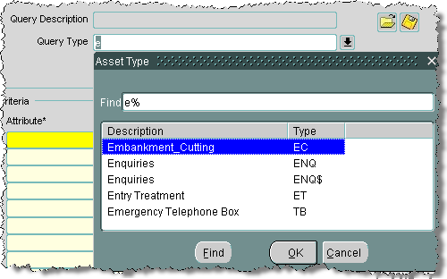

Only those Asset Types to which the User has been granted Role based access will be available.

*Query Builder allows the user to search for additional objects that have been specially defined for use in Query Builder, Alert Manager and Audit Manager. These new object types have been defined as special foreign table assets and may be identified by virtue of the fact their Asset code ends with a ‘$’.*



Note

*The following Objects that are currently available are as follows:*

* *WOR$ - Work Orders*
* *WOL$ - Work Order Lines*
* *DEF$ - Defects*
* *BOQ$ - BOQ Items*
* *ENQ$ - Enquiries*
* *PRO$ - Process Alert*

*The pick list includes both the objects 4 character mnemonic as well as the object description allowing the user to search both fields.*

Ignore Case (Optional) (Checkbox)

The ignore case checkbox acts on the data entered in the criteria panel below, this forces the system to ignore the case of any text values entered.

Figure 5

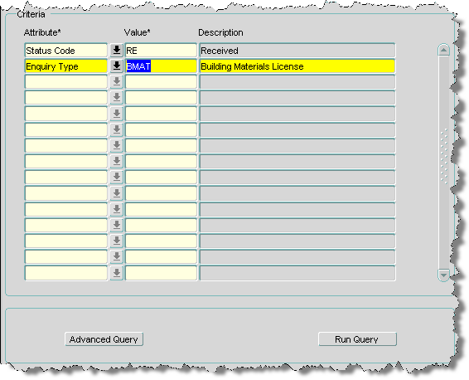

Query Criteria

When ***Query Builder*** is used in ‘Standard mode’ (the default) the condition of the selected attribute is always ‘=’ (i.e. wildcards cannot be used) and the relationship between subsequent attributes values is always an ‘AND’ relationship when using multiple attribute criteria. To create more complex search criteria press the **[Advanced Query]** button at the bottom of the Query Builder panel.

Attribute List

Enter the value(s) for the required Attributes to be matched. The content of this list will depend on the query type selected.

Value

Enter a value for the selected attribute. A description will be displayed if appropriate.

If the attribute value is validated against a look up, Query Builder uses the lookup code value with the meaning being displayed in the adjacent field if appropriate.

The list of allowable attribute values will display both the lookup code Value and its Meaning.

The list of the available values may be ordered by the Value or by the Meaning by pressing the **[Value]** button or the **[Meaning]** button respectively.

The column used to determine the list will also determine which field (Value or Meaning) will be used when refining the search criteria to limit the values displayed. For example, to search for all values where the Meaning begins with ‘ALU’, press the **[Meaning]** button then enter ‘ALU% in the ‘Find’ field and press the [**Find**] button on the window.

Click on the required lookup value to select, and press the [**Select Values**] button. To close the window without selecting a value, press the [**Cancel**] button.

To clear out one set of query criteria select the Clear Record  button.

To reset the criteria and search for a new Object Type, clear the record first if necessary then enter a new Query Type in the top of the panel.

To execute the search and display the results in the results tab press the [**Run Query**] button.

Figure 6

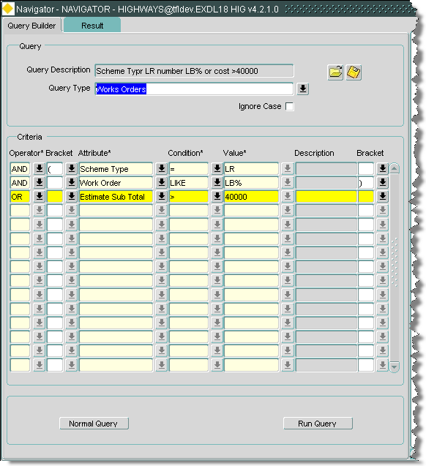

Query Builder – Advanced Query Panel

The ‘Advanced’ Query panel of Query Builder allows a more complex query to be constructed where, if multiple attributes are selected for a selected object, the relationship between the attributes may be defined as an 'AND' or 'OR' relationship and attribute value conditions may be defined as ‘greater than’, ‘less than’, ‘like’ etc. Attribute criteria may also be nested with 5 levels of nesting available if required.

The ‘Advanced’ Search panel is only available once an Object (Asset) Type has been selected and the [Advanced Query] button pressed.

*When the [Advanced Query] button is pressed and basic query criteria will be displayed in the advanced query panel, all the criteria will have an ‘AND’ relationship.*



Note

*If the [Normal Query] button is pressed while building an advanced query the following message will be displayed:*

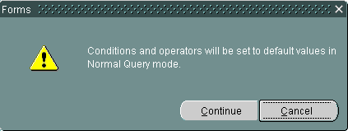

*If continue is selected the advanced query criteria will be reset to an ‘AND’ relationship with ‘=’ as the condition. The remaining query may be meaningless under these circumstances.*

*If the advanced query is needed the user should save the query for future use* (Figure 8).

Query Type (Display Only)

The Object Type description already selected will be displayed.

Figure 7

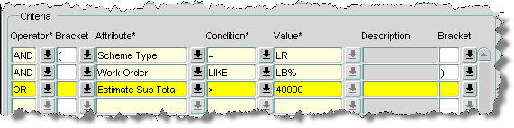

Attribute Criteria Panel

The Attributes Criteria panel is used to define the Attributes and the associated value of the selected Object Type to be used within the search. If multiple Attributes are selected the relationship between the Attributes may be defined as an 'AND' or 'OR' relationship. Attribute criteria may also be nested with 5 levels of nesting available if required by using the Pre and Post brackets as required.

Operator (Required) List

Select the required Boolean connector.

The operator of the first query criteria value must always be ‘AND’

Bracket List

If required select the appropriate Pre Bracket.

Attribute (Required) List

Select the Attribute of the selected Item to be used in the Gazetteer Filter.

Condition (Required) List

Enter the condition for the selected attribute.

These are a subset of the standard Oracle conditions and are set up and maintained by exor staff using ***Domains - HIG9120*** and updating the ***PBI_SR_COND*** option.



Note

***These options should not be updated by the customer as some conditions are not appropriate for use within the Query Builder Module.***

*If a ‘BETWEEN’ condition is required, for example, ‘BETWEEN 10,000 and 13,000’ the following should be used:*

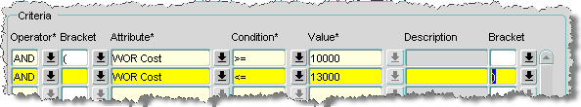

*If an ‘IN’ condition is required, for example, one of the following list ‘SS, LR or RD’ the following should be used:*

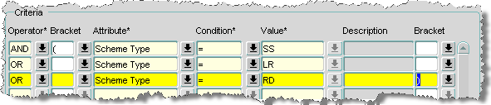

Value (Required) List

Enter the required ‘search’ value for the currently selected Attribute. If the attribute values are held in a Domain, the List of Values may be called and the description of the selected value will be displayed.

Bracket (Optional) List

If required select the appropriate Post Bracket.

To return to the ‘Normal’ Query panel press the **[Normal Query]** button.

To run the Query and display the results either press the **[Run Query]** button or select the Result tab .



Note

*When using date fields, the ‘sysdate’ (todays date) may be used to good effect, for example to search for all the work orders that have been raised in the ‘last 10 days’ and ‘not instructed’ the following may be used:*

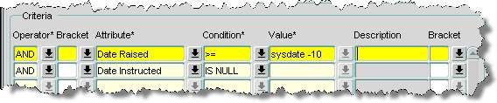

Figure 8

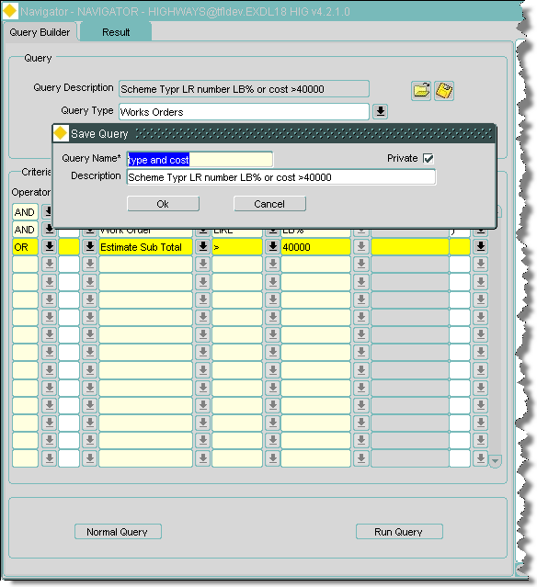

Saving the Query Criteria

Query Criteria may be saved and re-used at any time using the **[Save]** icon adjacent to the ‘Query Description’ field.

When saving a Query the User has an option to make in either ‘Private’ or ‘Public’. Private Queries are only available to the User who created it whilst Public Queries are avilable to all Users.

To save a Query press the **[Save]** button adjacent to the ‘Query Description’ field.

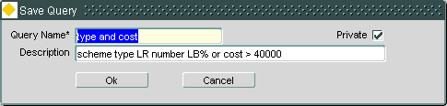

Query Name (Required)

Enter a unique name for the Query Criteria.

Description (Optional)

Enter a meaningful description for the Query Criteria.

Private (Checkbox)

To make the Query ‘Private’ and therefore not available to other Users tick the ‘Private’ Checkbox.

Press **[OK]** to Save the Query criteria.

Loading a Saved Query

To use a previously saved Query press the **[Load Query]** (Figure 9) button adjacent to the ‘Query Description’ field.

Figure 9

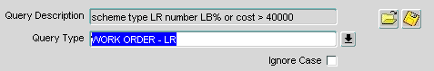

The ‘Load Searches For All Query Types’ window (Figure 10) will be displayed showing all ‘Public’ searches and the ‘Private’ Searches for the current User. This is a non updateable window showing the complete Query Criteria.

Figure 10

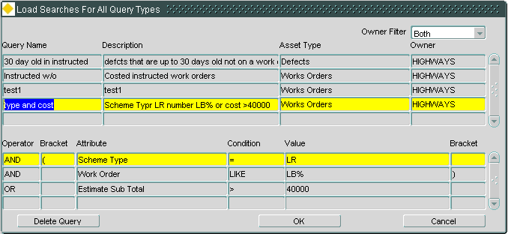

The list of available Searches can be restricted to either ‘Private’ or ‘Public’ Searches by applying a filter by pressing the drop list icon on the ‘Owner Filter’ field.

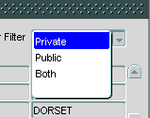

Highlight the required saved Search criteria and press **[OK]**. The Query Criteria will be displayed within Query Builder in either the Standard or Advanced mode depending on how the saved query was created.

Deleting a Saved Query

To delete a previously saved Query, press the **[Load Query]** button, select the required record and press the **[Delete Query]** button.

If an attempt is made to delete a saved query that is linked to an alret the following error will be displayed.

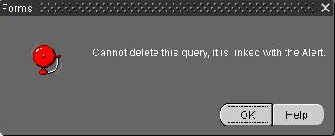

Figure 11

pin

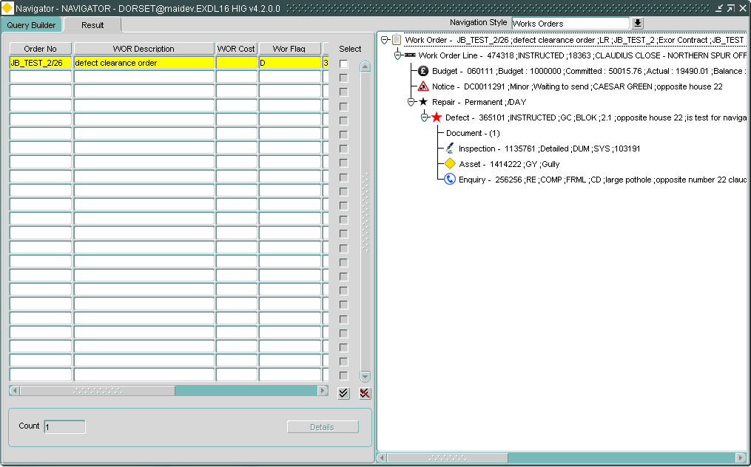

Results Grid

The results of the ***Query Builder*** search are displayed in a Grid format which displays the Objects attributes for all records which match the query criteria. This enables confirmation that the correct item(s) has been found, or to select the desired record from all records that match the search criteria.

Only those attributes flagged as ‘Displayed’ in the ***Asset Metamodel – NM0410*** module (Refer to the Asset Manager System Admin Guide) will be displayed within the Results Grid.

The attribute column widths are fixed to allow a reasonable display of column title and data, the width of each column is based on the data type of the field to be displayed and are as follows:

* *Date fields – 25mm*
* *Number fields – 20mm*
* *Character fields,* 
  + *if the width field in Asset Metamodel – NM0410 is set to less than 30 it is 25mm*
  + *if the width field in Asset Metamodel – NM0410 is set to more than 30 it is 50mm*

Hint Text is available to view the Column Heading if the Grid Column width is less than the Display Name.

Attribute values and data Items within the Grid may be viewed by using the horizontal and vertical scroll bars respectively.

Note *When results are displayed within the results grid the attribute values displayed may be the unique system generated value for that record, this is to keep the keep the performance of the query to its maximum as the grid may contain many hundreds of thousands of records. The actual values may be seen in the navigator panel if appropriate.*

*When writing the query, the actual attribute value is presented to the user in the appropriate picklist.*

A count of the total number of records retrieved will be displayed at the bottom of the form in the Count window as shown in Figure 12.

Figure 12

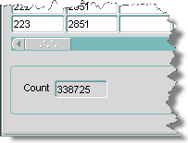

Figure 13

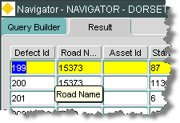

Hint Text

The entire Attribute Name is displayed in the ‘hint text’ that is automatically displayed when the mouse cursor is hovered over any value within the column. An example is shown in Figure 13.

Figure 14

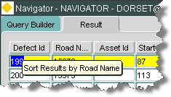

Sorting Results

Standard querying techniques are available for all the columns within the results grid, wildcards included.

Results within the Grid may be sorted by any of the displayed Attributes by pressing the Attribute Names (column headings), which are also ‘Sort’ buttons. The first time a heading is pressed the records are sort in ascending order. If pressed again the records within the Grid will be sorted in descending order of the selected Attribute. A ‘carat’ (^) symbol or lower case ‘v’ (v) is displayed adjacent to the Attribute Name if the column width allows to indicate that the data has been sorted in ascending or descending order respectively as shown in Figure 15.

Figure 15

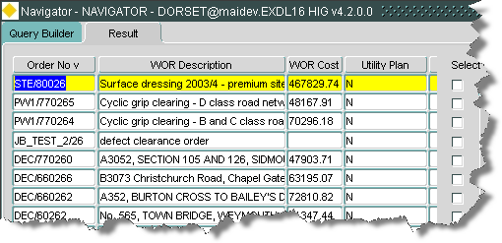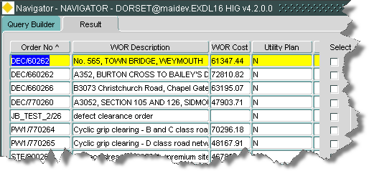

Selecting Data Items from the Grid for Display within a form

If the data items in the results grid have an associated form within exor they can be viewed by checking the ‘select’ check box followed by the [Details] button.

The [Details] button will only be available if an appropriate form exists.

Selecting a Data Item from the Grid for Display within navigator

The following data items may be displayed within the navigator panel from Query Builder, These are the only items that can be viewed within the navigator panel as they have been specifically defined for that purpose:

* *WOR$ - Work Orders*
* *WOL$ - Work Order Lines*
* *DEF$ - Defects*
* *ENQ$ - Enquiries*

Figure 16

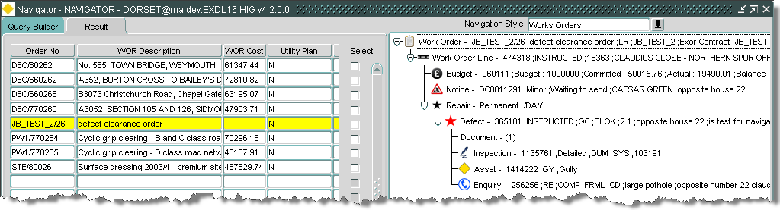

When the required data item is selected and hilighted as shown above the corresponding data will be displayed in the Navigator panel.

For additional information on the Navigator Panel see Figure 17

Figure 17

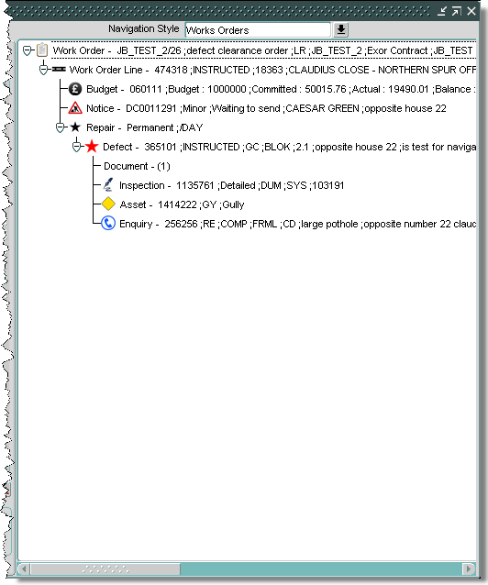

Navigator Panel

The Navigator panel within ***Query Builder*** provides the user with a view of all associated ‘child’ records for the selected ‘parent’ record. Only one parent record will be displayed at any time within the Navigator panel, the following parent record types are available:

* Work Orders
* Defects
* Enquiries

The ‘Navigation Style’ field will default to one of the above record types when navigator is populated but may be changed to alter the focus of the display providing a related data type is available within the hierarchy.

*If navigator is called from a form, the form will define the navigation style, in this case the focus may not be changed as the navigation style is pre-defined for that record type.*

For example, the default display for a work order record that has been selected from the query panel will be:

Figure 18

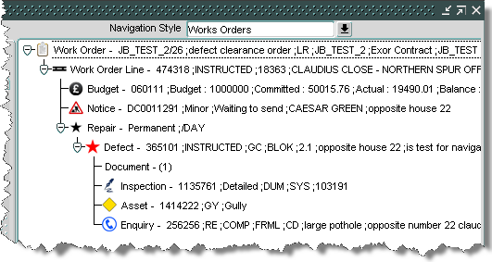

With the navigation style changed to focus on the Defect the following will be displayed:

If a defect has more than one repair, all repairs will be displayed.

Figure 19

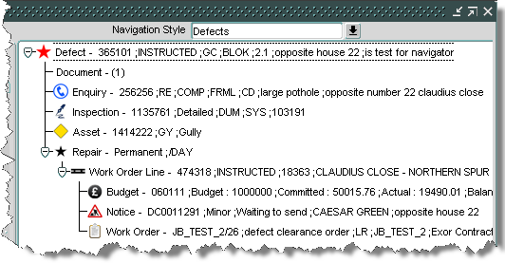

With the navigation style changed to focus on the Enquiry the following will be displayed:

Figure 20

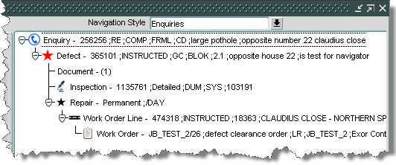



For each navigation style a set of associated records are displayed in a hierarchy that relate directly to the item type being viewed with a summary of the information displayed adjacent to each record type.

If the appropriate relationships exist between the records the following related information can be displayed providing the user has the required permissions on the associated data and modules:

* Work Orders
* Work Order Lines
* Budget
* TMA Notice
* Repair
* Defect
* Inspection
* Asset
* Enquiry
* Document
* Audit

Work Orders

Double click this record to call ***Work Orders - MAI3800***.

The following summary information will be displayed for the selected Work Order:

* Work Order Id
* Work Order Description
* Scheme Type Code
* Contract Code
* Contract Code Description
* Contractor Code
* Contractor Code Description

Work Order Lines

Double click this record to call ***Work Orders – MAI3800*** with the focus on the selected work order line.

The following summary information will be displayed for the selected Work Order Line:

* Work Order Line Id
* Work Order Line Status Code
* Road Id
* Road Description

Budget

Double click this record to call ***Budgets - MAI3660.***

The following summary information will be displayed for the selected Budget:

* Budget Code
* Budget: Financial Value
* Committed: Financial Value
* Actual: Financial Value
* Balance: Financial Value

TMA Notice

Double click this record to call ***Works - TMA1000***.

The following summary information will be displayed for the selected TMA Notice:

* Works Reference
* Works Category Description
* Status Description
* Street Description
* Location Description

Repair

Double click this record to call ***Defects – MAI3806***.

Right mouse click will display the option to select ***Inspections – MAI3808***

The following summary information will be displayed for the selected Repair:

* Repair Category
* Treatment Code

Defect

Double click this record to call ***Defects – MAI3806***.

Right mouse click will display the option to select ***Inspections – MAI3808.***

The following summary information will be displayed for the selected Defect:

* Defect Id
* Defect Status Code
* Activity Code
* Defect Code
* Priority Code
* Defect Location
* Defect Description

Inspection

Double click this record to call ***Inspections - MAI3808***.

The following summary information will be displayed for the selected Inspection:

* Inspection Id
* Inspection Type description
* Initiation Type code
* Weather Condition Code
* Inspectors Initials
* Inspection Batch number

Asset

Double click this record to call ***Asset Items – NM0510***.

Right button click will display the option to select ***Asset Maintenance – NM0590.***

The following summary information will be displayed for the selected Asset:

* Unique Id (Primary Key)
* Asset Type Code
* Asset Type Description

Enquiry

Double click this record to call ***Enquiries – DOC0150***.

The following summary information will be displayed for the selected Enquiry:

* Enquiry Id
* Status Code
* Category Code
* Class Code
* Type Code
* Description
* Location Description

Document

Double click this record to display the document.

The following summary information will be displayed for the selected document:

* Document Id
* Document Type Code
* Document Reference Number
* Location code
* Date Issued

Audit

If the record has an associated audit record, the audits may be viewed by selecting the right mouse button, this will call ***Audits – HIG1505***.

An example of this is shown below:

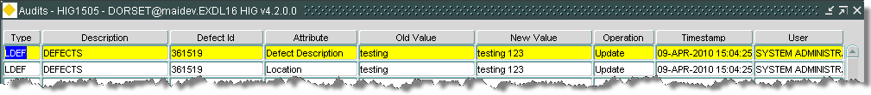

Additional Examples – Work order Lines

In the following example, the automatic work order generation process has created two separate work orders, each with one work order line, one for each repair of a selected defect (237982).

When querying back work order line details (WOL$) within query builder, navigator will display the hierarchy for each individual work order line, if a given defect (237982) has two repairs and each repair is on a separate work orders there will be 2 records displayed, one for each line as shown below:

Work Order Line id: 211029:

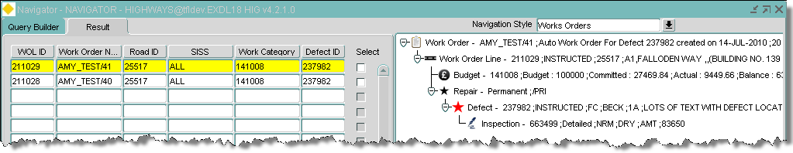

Work Order Line id: 211028:

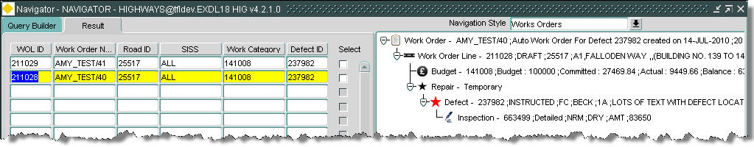

If the navigation style is changed to focus on the defect information for either work order line record, the following will be displayed showing all associated information for the defect (237982).

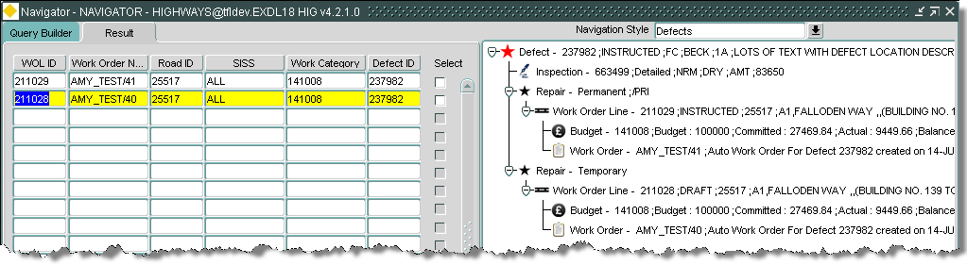

Additional Examples – Enquiries

In the following example an enquiry has a defect associated to it, this defect has two repairs, both of which are on different work orders, this will be displayed in Navigator as shown below:

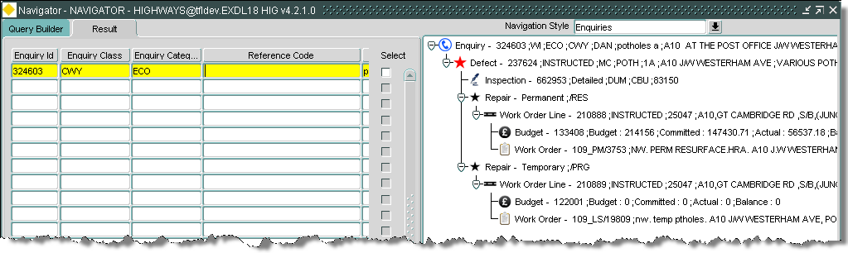

If the navigation style is changed to focus on the defect information for the enquiry, the following will be displayed showing all associated information for the defect, this also includes a reference to an asset that has been linked to the defect.

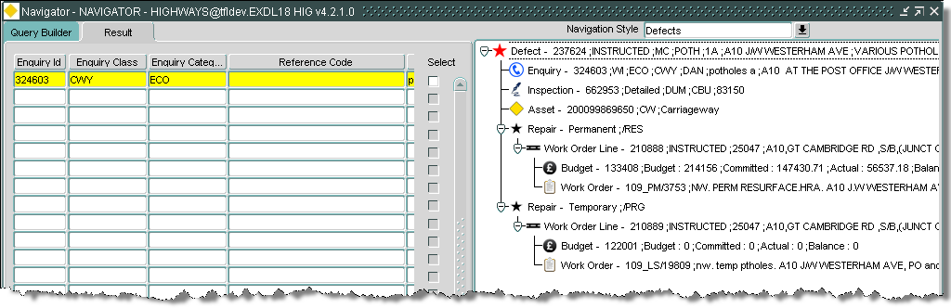

The asset is not displayed against the enquiry as it has not been linked to the actual enquiry itself. If a restriction was not placed on what is displayed there could potentially be multiple records in the hierarchy leading to confusion on what is being viewed.

If the navigation style is changed to focus on the work order information the following will be displayed for each work order:

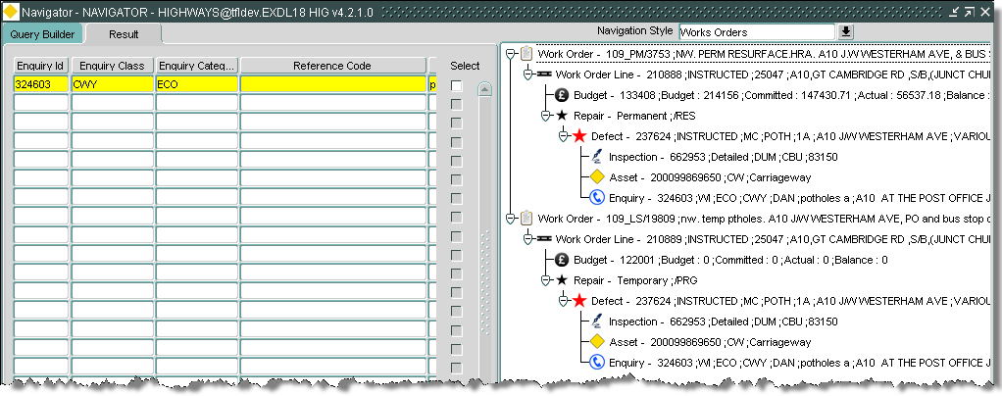

Additional Examples – Multiple Records

If multiple records are found and displayed within navigator they are displayed expanded by default as shown:

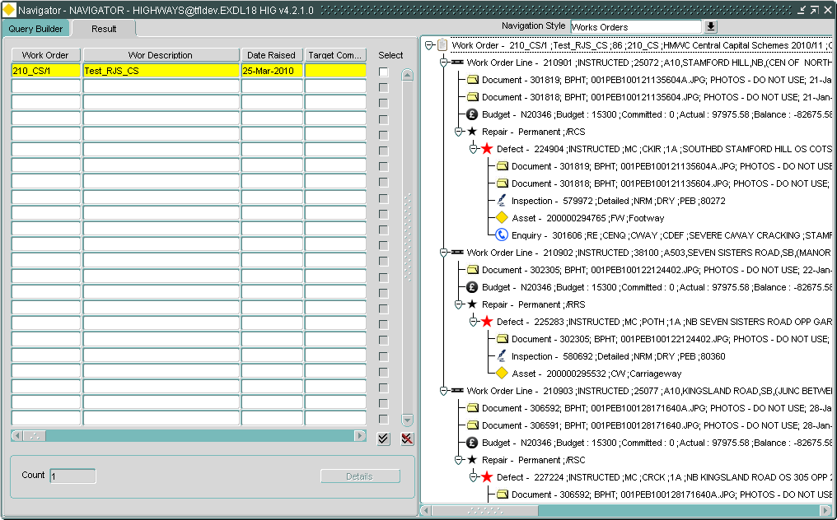

To view a summary of the information the user will have to either use the scroll bars or collapse the data manually as shown:

